

**Commercial Launch Letter for Roaming Services**

This is to confirm that on the **10th** **May, 2023**

**STC KUWAIT (KWTKT)**

and

**Salt (Liechtenstein) AG (LIEVE)**

agree to extend the commercial roaming service per below table.

Service is launched by default.

|  |  |  |  |  |
| --- | --- | --- | --- | --- |
| **Service** | **HPMN** | **VPMN** | **Bilateral/Unilateral** | **Comment** |
| LTE |  |  | Bilateral |  |

The commercial service is in accordance with the conditions set out in the International Roaming Agreement signed by both Parties.   
  
Date: 04.05.2023 Date: 03.05.2023 Place: Kuwait Place: Balzers

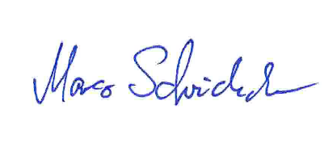

................................................................ ………………………………………

For and on behalf of STC,Kuwait For and on behalf of Salt (Liechtenstein) AG

Name Sajid Amin Name: Mr. Marco Scheidecker

Title: Senior Roaming Engineer Title : Roaming Manager